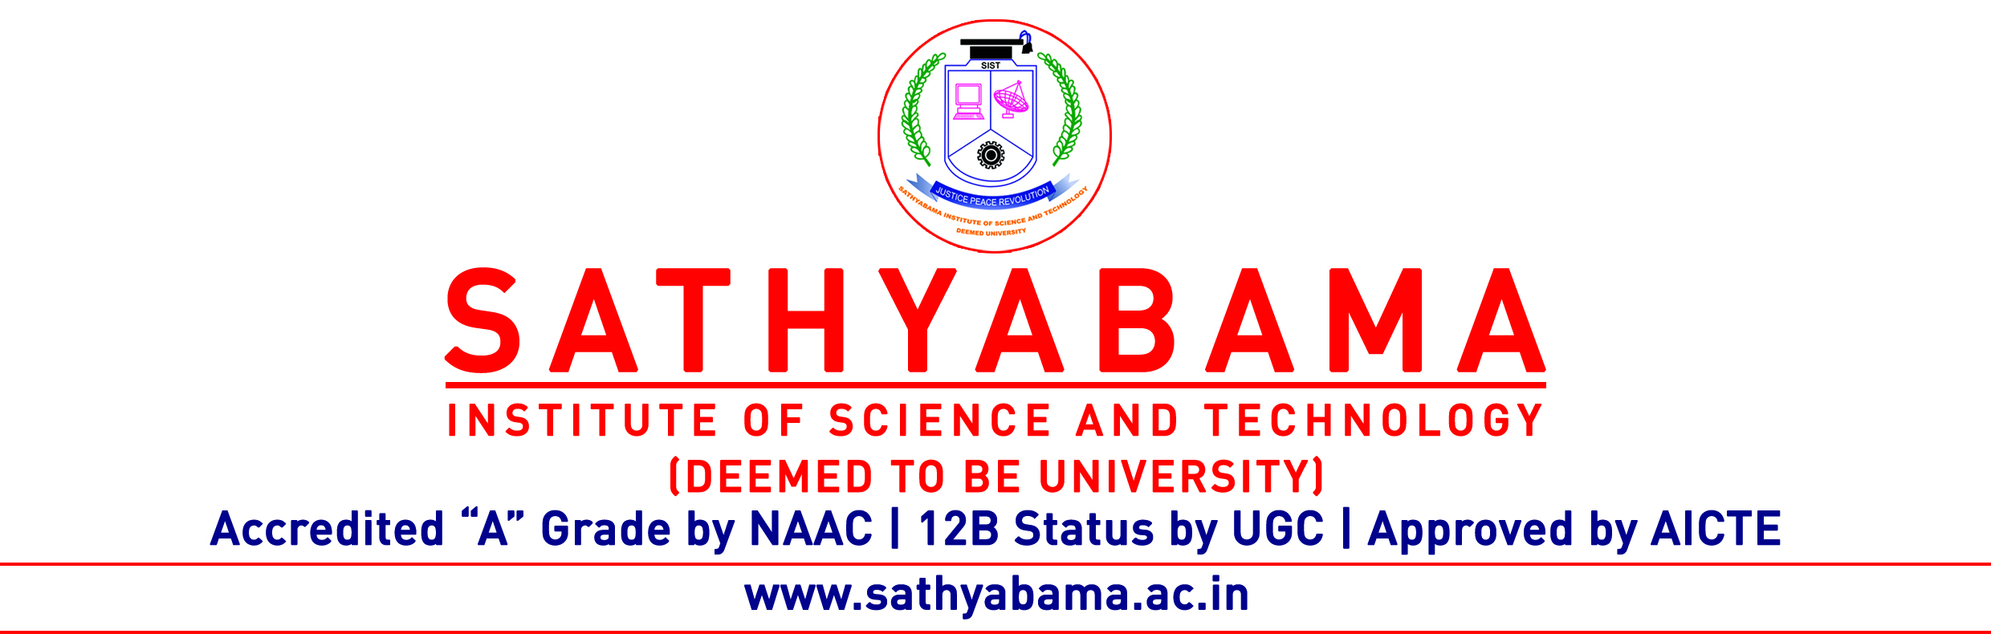
Form: 15
For Applying Course Completion Certificate

Name of the Scholar |  |  |  |  |  | Total No. of Subject Completed
Registration Number |  |  |  |  |  | Total No. of Credits Earned
S.No | Subject Name |  | Subject Code | Credits | Year of Passing | Course completed at SIST/NPTEL | Any change in the subject after first DC meeting.
 |  |  |  |  |  |  | Yes/No
 |  |  |  |  |  |  | Yes/No
 |  |  |  |  |  |  | Yes/No
 |  |  |  |  |  |  | Yes/No
 |  | First DC Meeting minutes and All result copies should be attached.
 |  | Note :If any changes are made in the subject attach proof of Form 5

Signature of the Research scholar

